Section I: Scenario Demographics

Scenario Title: | Altered LOC
Date of Development: | 12/02/2015 (DD/MM/YYYY)
Target Learning Group: | Juniors (PGY 1 – 2) Seniors (PGY ≥ 3) All Groups

Section II: Scenario Developers

Scenario Developer(s): | Kyla Caners
Affiliations/Institution(s): | McMaster University
Contact E-mail (optional): | kcaners@gmail.com

Section III: Curriculum Integration

Learning Goals & Objectives
Educational Goal: | To help participants develop an approach to the initial work-up and management of a patient with decreased LOC
CRM Objectives: | Prioritize interventions and treatments in the management of a complex altered LOC patient and communicate priorities effectively with team members.
Medical Objectives: | 1) Identify complex differential diagnosis for altered LOC and initiate appropriate diagnostic work-up.  2) Identify need for airway management in a patient with altered LOC.  3) Demonstrate a reasonable approach to securing the airway in a hypotensive, altered patient.

Case Summary: Brief Summary of Case Progression and Major Events
An 82 year old man arrives to the ED by EMS with a GCS of 7. He smells of urine and feces, and apparently has not been seen in 4 days. He is hypotensive and tachycardic. With simple fluid resuscitation (1-2L), the BP will improve. Learners are to organize a broad diagnostic work-up and coverage with broad-spectrum antibiotics. They must also recognize the need to intubate. If they do not, the patient will vomit and have a resultant desaturation. The case ends after successful workup and intubation.

References
Marx, J. A., Hockberger, R. S., Walls, R. M., & Adams, J. (2013). Rosen's emergency medicine: Concepts and clinical practice. St. Louis: Mosby.

Section IV: Scenario Script

A. Scenario Cast & Realism
Patient: | Computerized Mannequin |  |  |  |  | Realism:  Select most important dimension(s) |  |  | Conceptual
 | Mannequin |  |  |  |  |  |  |  | Physical
 | Standardized Patient |  |  |  |  |  |  |  | Emotional/Experiential
 | Hybrid |  |  |  |  |  |  |  | Other:
 | Task Trainer |  |  |  |  |  |  |  | N/A
Confederates | Brief Description of Role
EMS attendant | Gives case description, makes it clear that patient smells foul.
B. Required Monitors
EKG Leads/Wires |  |  | Temperature Probe |  |  |  | Central Venous Line
NIBP Cuff |  |  | Defibrillator Pads |  |  |  | Capnography
Pulse Oximeter |  |  | Arterial Line |  |  |  | Other:
C. Required Equipment
Gloves |  |  | Nasal Prongs |  |  |  | Scalpel
Stethoscope |  |  | Venturi Mask |  |  |  | Tube Thoracostomy Kit
Defibrillator |  |  | Non-Rebreather Mask |  |  |  | Cricothyroidotomy Kit
IV Bags/Lines |  |  | Bag Valve Mask |  |  |  | Thoracotomy Kit
IV Push Medications |  |  | Laryngoscope |  |  |  | Central Line Kit
PO Tabs |  |  | Video Assisted Laryngoscope |  |  |  | Arterial Line Kit
Blood Products |  |  | ET Tubes |  |  |  | Other: OG and Tumey syringe
Intraosseous Set-up |  |  | LMA |  |  |  | Other: foley set-up
D. Moulage
If possible: torn or dirty-looking clothes, wig with patches of matted hair. Stains to smear on mannequin. Pressure sores.

E. Approximate Timing
Set-Up: |  | 10 min |  | Scenario: | 12 min |  |  | Debriefing: |  | 15 min

Section V: Patient Data and Baseline State

A. Clinical Vignette: To Read Aloud at Beginning of Case
You are working in a community ED. Mr. Alito Bizzaro is brought in by EMS into a resuscitation room with altered LOC. He is known to be reclusive, but always picks up his paper at 10am. His neighbours had not seen him pick up his paper in 4 days, and so they called. The patient was found on the floor in his apartment near the doorway to the bathroom. He is 82 years old and lives alone. His apartment was unkempt. The patient is covered in urine and feces.
B. Patient Profile and History
Patient Name: Alito Bizzaro |  |  |  |  |  | Age: 82 |  |  |  |  |  |  |  | Weight: 70kg
Gender: M F |  |  |  |  |  | Code Status: Full
Chief Complaint: altered LOC
History of Presenting Illness: Last seen to pick up paper 4 days ago. Neighbours called because it is unusual for him to not pick up the paper. He lives alone and the neighbour believes the patient’s sons stopped trying to communicate with him. The neighbour believes the patient hasn’t ever seen a doctor.
Past Medical History: |  | Unknown |  |  |  |  | Medications: |  |  |  |  | Local drug printout shows no meds
Allergies: None.
Social History: Reclusive, lives alone. Only seen to pick up his paper every day.
Family History: Unable to obtain any hx.
Review of Systems: |  | CNS: |  |  | Unable
 |  | HEENT: |  |  | Unable
 |  | CVS: |  |  | Unable
 |  | RESP: |  |  | Unable
 |  | GI: |  |  | Unable
 |  | GU: |  |  | Unable
 |  | MSK: |  |  | Unable |  |  |  |  |  |  |  | INT: |  | Unable
C. Baseline Simulator State and Physical Exam
No Monitor Display |  |  |  | Monitor On, no data displayed |  |  |  |  |  |  | Monitor on Standard Display
HR: 130/min |  |  | BP: 90/52 |  |  |  |  | RR:22/min |  |  |  |  |  |  | O₂SAT: 92 % RA
T: 35.7ºC |  |  | Glucose: 6.2 mmol/L |  |  |  |  | GCS: 7 (E1V2M4)
General Status: Smells of urine/feces. Grunting only. Looks unwell.
CNS: | GCS as above. Withdraws to pain on R. Nothing on L.
HEENT: | Pressure sore to cheek, edema to face. PERLA 3mm.
CVS: | No murmur, NSR.
RESP: | Crackles to R lung, normal BS on L
ABDO: | Soft, NT.
GU: | Nil.
MSK: | Normal ROM all joints. No signs trauma. |  |  |  |  |  |  |  | SKIN: | Pressure sore to L hip

Scenario States, Modifiers and Progression
Patient State | Patient Status | Learner Actions, Modifiers & Triggers to Move to Next State
1. Baseline State  Rhythm: sinus tach  HR: 130/min  BP: 90/52  RR: 22/min  O₂SAT: 92 %  T: 35.7ºC | GCS 7 (E1 V2 grunts/moans M4 withdraws on R, not on L)  Minimally responsive, somnolent | Learner Actions  -IV, O2, Monitors  -Physical exam  -Order labs and urine  -Order ECG and CXR  -Check cap sugar: 6.2  -Broad-spectrum Abx  -Consider CT head | Modifiers  Changes to patient condition based on learner action  -Bolus 1L fluid BP 95/65, HR 115  -No fluid given BP 80/40  -02 placed sats to 97%  Triggers  For progression to next state  -Intubation 2. Intubation  -5 minutes 3. Aspiration
2. Intubation  HR 110  BP 105/65  O2 sats 98% if pre-oxygenating | Unchanged | Learner Actions  -Select appropriate meds  -Have pressor at bedside  -Intubate  -OG placement  -CXR to confirm | Modifiers  -If use propofol BP to 80/40  Triggers  -Intubation 5. Resolution
3. Aspiration  HR 120  BP 130/75  O2 86% on NRB  RR 24 | Patient suddenly has large amount emesis, then difficult resps | Learner Actions  -Turn patient to side  -Suction and clear emesis  -Identify need to intubate | Modifiers  Triggers  -Intubation 2. Intubation  -No intubation 4. PEA arrest
4. PEA Arrest  PEA rhythm  BP -/-  O2 70% | Patient pulseless | Learner Actions  -Maintain quality CPR  -Epinephrine q3 min  -Intubate | Modifiers  Triggers  -12 min 5. Resolution  -3 rounds CPR 5. Resolution
5. Resolution  HR 105  BP 105/65  O2 100%  RR 12 (vent) | Patient intubated +/- sedated | Learner Actions  -CT head  -Consult ICU | END OF SCENARIO
Section VI: Scenario Progression

Section VII: Supporting Documents, Laboratory Results, & Multimedia

Laboratory Results
No blood work is provided during the case.

Images (ECGs, CXRs, etc.)
CXR – post-intubation (normal)  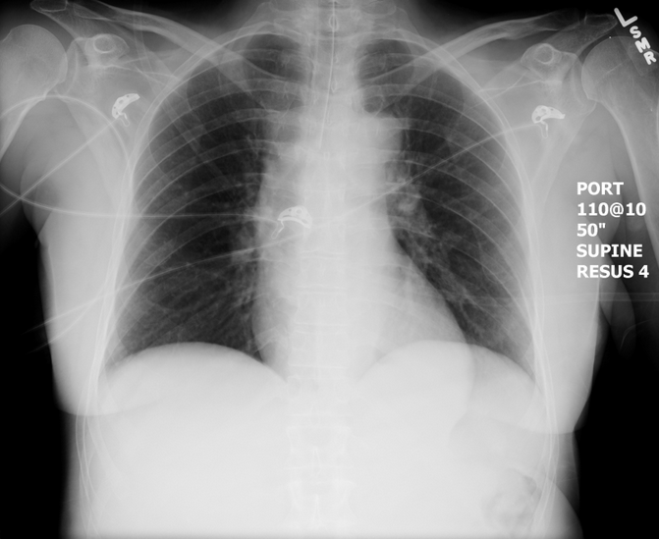  Source: https://emcow.files.wordpress.com/  2012/11/normal-intubation2.jpg | ECG – sinus tachycardia  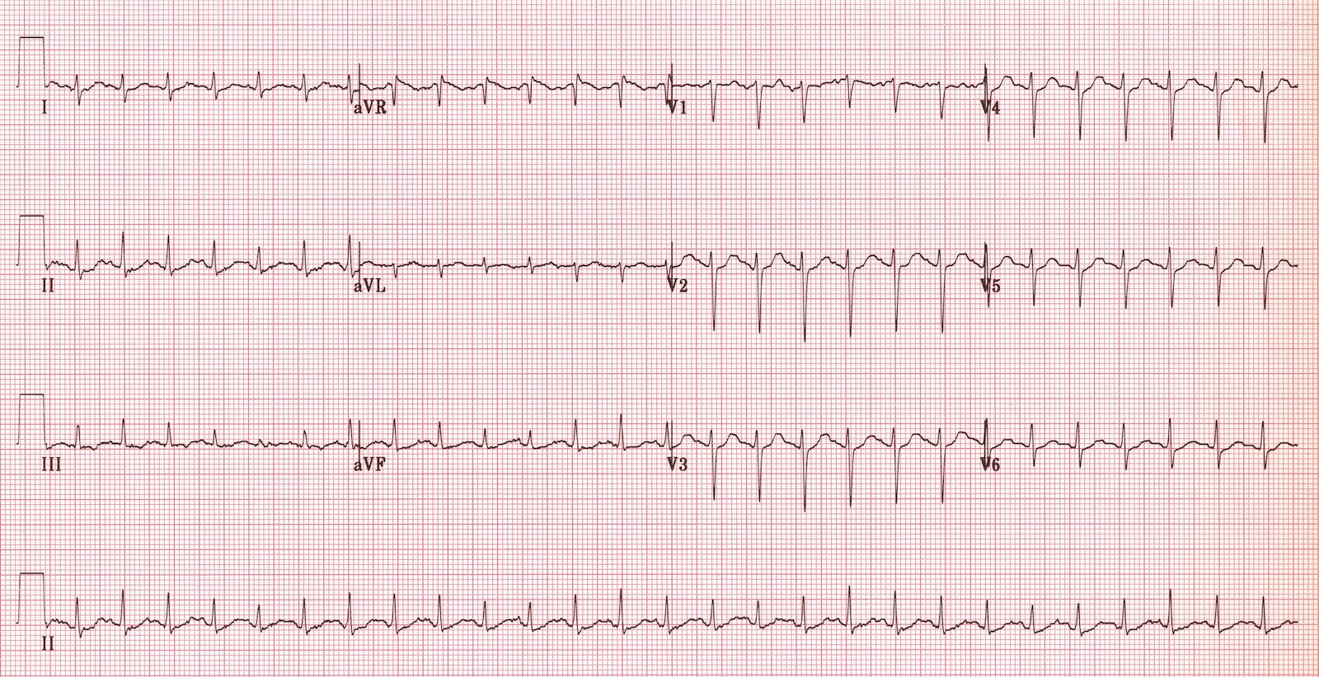  Source: http://cdn.lifeinthefastlane.com/wp-content/uploads/2011/12/sinus-tachycardia.jpg

Section VIII: Debriefing Guide

General Debriefing Plan
Individual | Group |  | With Video | Without Video
Objectives
Educational Goal: |  | To help participants develop an approach to the initial work-up and management of a patient with decreased LOC
CRM Objectives: |  | Prioritize interventions and treatments in the management of a complex altered LOC patient and communicate priorities effectively with team members.
Medical Objectives: |  | 1) Identify complex ddx for altered LOC and initiate appropriate diagnostic work-up.  2) Identify need for airway management in a patient with altered LOC.  3) Demonstrate a reasonable approach to securing the airway in a hypotensive, altered patient.
Sample Questions for Debriefing
- How did it feel at the outset of the case? Did the team feel like the orders and priorities were clear?
- When did you identify the need to intubate this patient? What made it clear to you that the patient needed intubation?
- In a patient who has altered LOC and can’t give a history, what is in your differential diagnosis? How do you tailor your blood work and initial investigations to address this differential?
- What medications are safe to use for intubation in a patient with hypotension and possible sepsis?
Key Moments
Initial workup – prioritizing BP before airway, ensuring complete work-up
Recognition of need to intubate
Peri-intubation: appropriate choices, safe preparation

